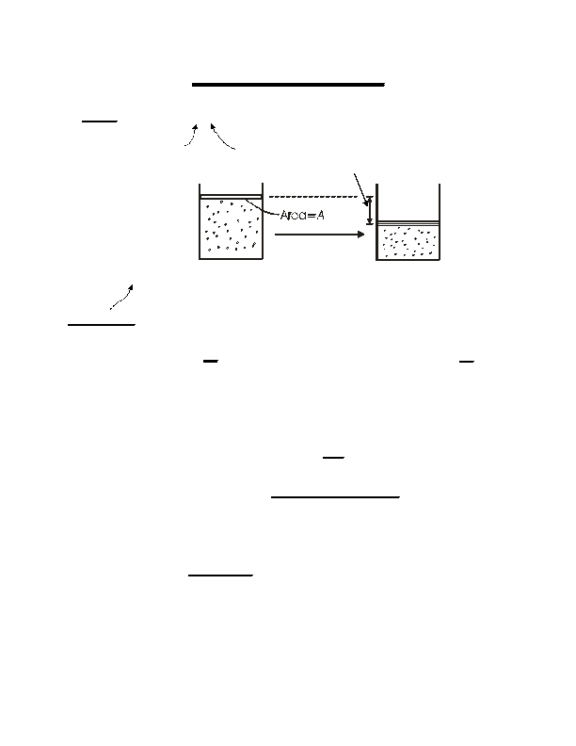
5.60 Spring 2008
Lecture #2
page 1
• Work:
Work, Heat, and the First Law

w = F ⋅ A
applied force
distance

pext
A
Expansion work

F = p extA
pext
w = −( extp A)A = − extp ∆V
convention:
Having a "-" sign here implies w > 0 if ∆V < 0 , that
is, positive work means that the surroundings do
work to the system. If the system does work on the
surroundings (∆V > 0) then w < 0.
If p
ext
is not constant, then we have to look at infinitesimal changes
d-w = −p extdV
Integral
d - means this is not an exact differential
w = − ∫ p extdV
2
1
depends on the path!!!
• Path dependence of w

Example: assume a reversible process so that pext
Ar (g, p 1, V 1)
Compression
V1
=
= p
Ar (g, p 2, V 2)
> V 2 and p 1 < p2
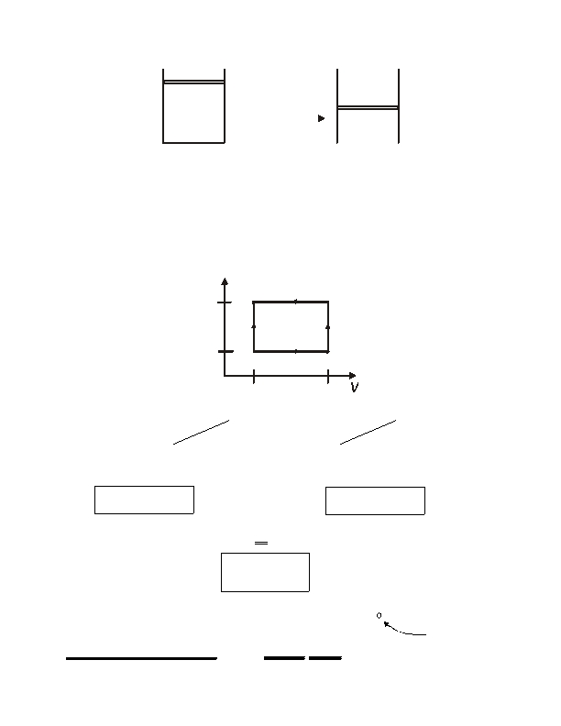
5.60 Spring 2008
Lecture #2
page 2
pext
= p1
pext
p 1,V1
compression
= p2

p 2,V

final
2
initial
Two paths:
(1) First
then
V 1 → V2
p 1 → p2
at p = p1
at
V = V2
(2) First p 1 → p2
then V 1 → V2
at V = V1
at p = p2
Ar(g, p 1, V 1) = Ar(g, p 1, V 2) = Ar(g, p 2, V 2)

p
p2
final
Ar(g, p 1, V 1) = Ar(g, p 2, V 1) = Ar(g, p 2, V 2)
(2)
p1
(1)

V2
init.

V1

V1 V2
= − ∫ p extdV − p dV
V1

= − ∫ p 2dV = −p (V V )
∫
ext
V1

V2

V1
2
2 −
1
w
(2)
= p 2 (V
1
−V )
2
w
= − ∫ p extdV − p dV
V2
= − ∫ pdV = −p (V V )
V2
V2
∫
ext
V1

V2

V1
1

= p 1 (V
1
1
2 −
1
w
(1)
− V )
2
w
(1)
(2)
(Note w > 0, work done to system to compress it)

w (1) ≠w (2) !!!
Note for the closed cycle [path (1)] - [path (2)],
w is not a state function
∫ dw ≠ 0
-
closed cycle
cannot write w = f(p,V)

5.60 Spring 2008
Lecture #2
page 3
WORK
Work (w) is not a function of state.
For a cyclic process, it is possible for ∫d-w ≠ 0
state 1
state 2
HEAT
That quantity flowing between the system and the
surroundings that can be used to change the temperature
of the system and/or the surroundings.
Sign convention:
If heat enters the system, then it is
positive.
Heat (q), like w, is a function of path. Not a state function

It is possible to have a change of state

(p 1, V 1, T 1) = (p 2, V 2, T 2)
adiabatically
(without heat transferred)
or
nonadiabatically.
Historically measured in calories
[1 cal = heat needed to raise 1 g H 2O 1°C,
from 14.5°C to 15.5°C]
The modern unit of heat (and work) is the Joule.

1 cal = 4.184 J
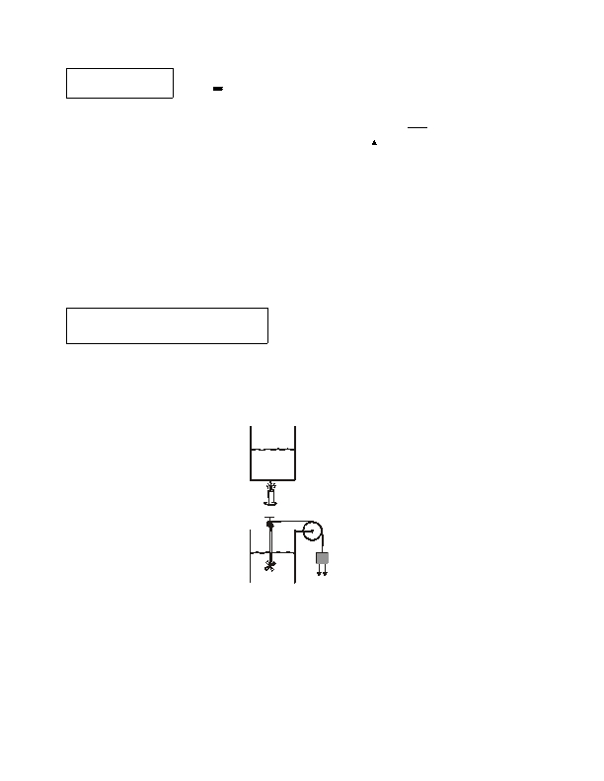
5.60 Spring 2008
Lecture #2
page 4
Heat Capacity
C
- connects heat with temperature
đq = Cpath
dT
or
C
path = ⎜
⎛ đq ⎞

⎝dT ⎠path⎟
Constant volume:
Constant volume:

∴ q = ∫
path

Equivalence of work and heat
heat capacity is path dependent

CV
Cp

C pathdT
[Joule (1840's)]
Joule showed that it's possible to raise the temperature of H 2O
(a) with only heat
T 1 → T2
(b) with only work
(weight falls &
churns propeller)
T 1 → T2

5.60 Spring 2008
Lecture #2
page 5
Experimentally it was found that

∫ (dw +dq ) = 0
-
-
⇒

⇒
The sum (w + q) is independent of path

This implies that there is a state function whose differential is
đw + đq

We define it as U, the "internal energy" or just "energy"

∴ dU = đw + đq

For a cyclic process ∫dU = 0

For a change from state 1 to state 2,
2
∆U = ∫ dU =U −U = q +w
1
2
1
does not depend on path
each depends on path individually, but not the sum

For fixed n, we just need to know 2 properties, e.g. (T, V), to fully
describe the system.

So U = U (T ,V ))

U is an extensive function (scales with system size).
U
=
U
n
is molar energy (intensive function)

5.60 Spring 2008
Lecture #2
page 6
THE FIRST LAW
Mathematical statement:
dU = -dq +-dw
or
∆U = q +w
or
− ∫ d-q = ∫ d-w
Corollary:
Conservation of energy
∆Usystem

⇒
= q +w

∆Uuniverse
= ∆Usystem
∆Usurroundings

+ ∆Usurroundings = 0
= −q −w
st
Clausius statement of 1 Law:

The energy of the universe is conserved.

